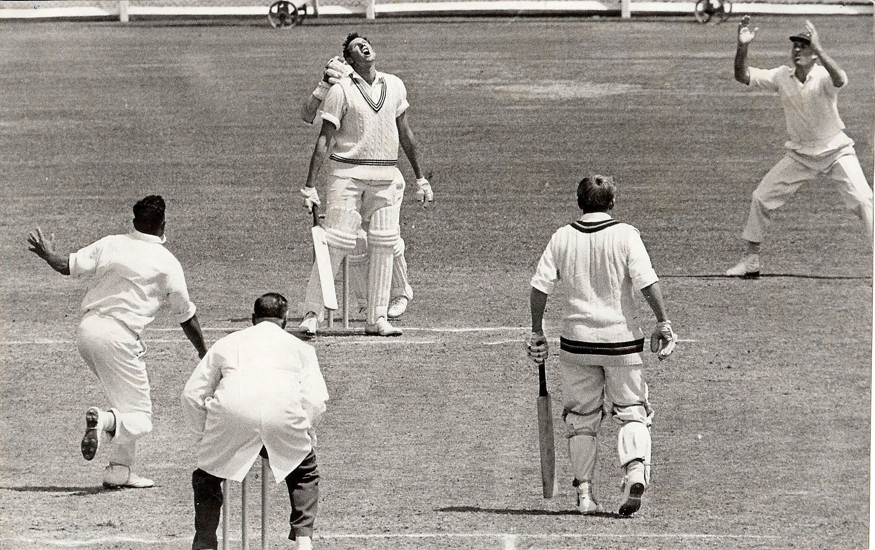

**BR Taylor plays and misses the ball. Bowler N Puna. ML Ryan the non striker. Lancaster Park 1 January 1966**

**Taylor was 82 unbeaten when the match concluded. He had a partnership of 76 for the sixth wicket with Ryan.**

**Northern Districts 244 and 115 Canterbury 172 and 188/7 Canterbury won by 3 wickets**